**DAILY ONLINE ACTIVITIES SUMMARY**

|  |  |  |  |
| --- | --- | --- | --- |
| **Date:** | 7/06/2020 | **Name:** | Krishnitha |
| **Sem & Sec** | 4th sem, A Section | **USN:** | 4AL18CS039 |
| **Online Test Summary** | | | |
| **Subject** | NA | | |
| **Max. Marks** | NA | **Score** | NA |
| **Certification Course Summary** | | | |
| **Course** | 1) Trailhead Basics  2) Python for Machine Learning | | |
| **Certificate Provider** | 1) Sales Force  2) Great Learning | **Duration:** | 1) 3 hrs  2) 45 min |
| **Coding Challenges** | | | |
| **Problem Statement:**  Write a C++ Program to swap two numbers using friend as a bridge concept. | | | |
| **Status:** Executed | | | |
| **Uploaded the report in GitHub** | | YES | |
| **If yes Repository name** | | <https://github.com/krishnitha/C-coding> | |
| **Uploaded the report in slack** | | YES | |

**Certification Course Details:**

Today I have done the Course named Trailhead Basics by Sales Force. I learnt about the data management which teaches how to import data and how to use the data import wizard in my trailhead playground.

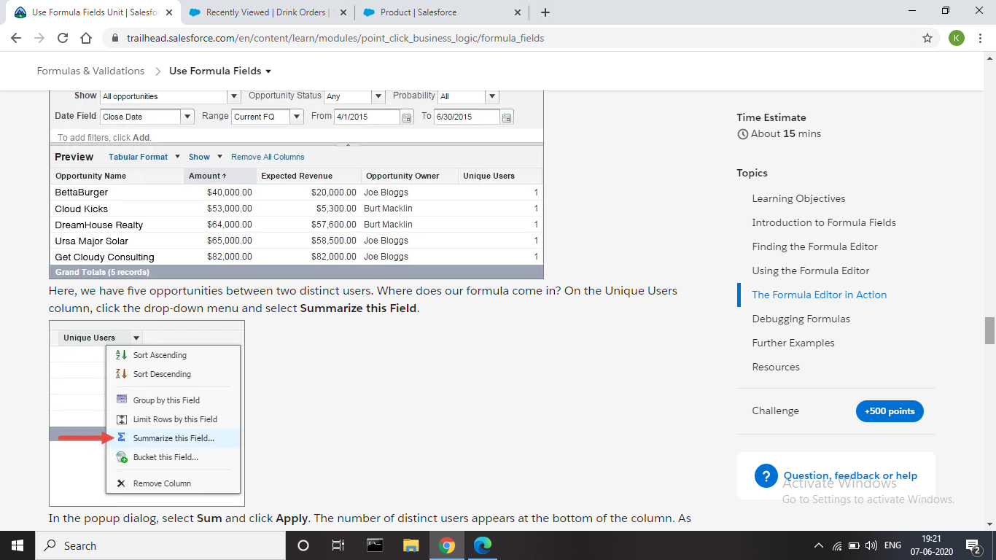

And also, I have completed the assessment of the course Python for Machine Learning and I have received the certificate of completion.

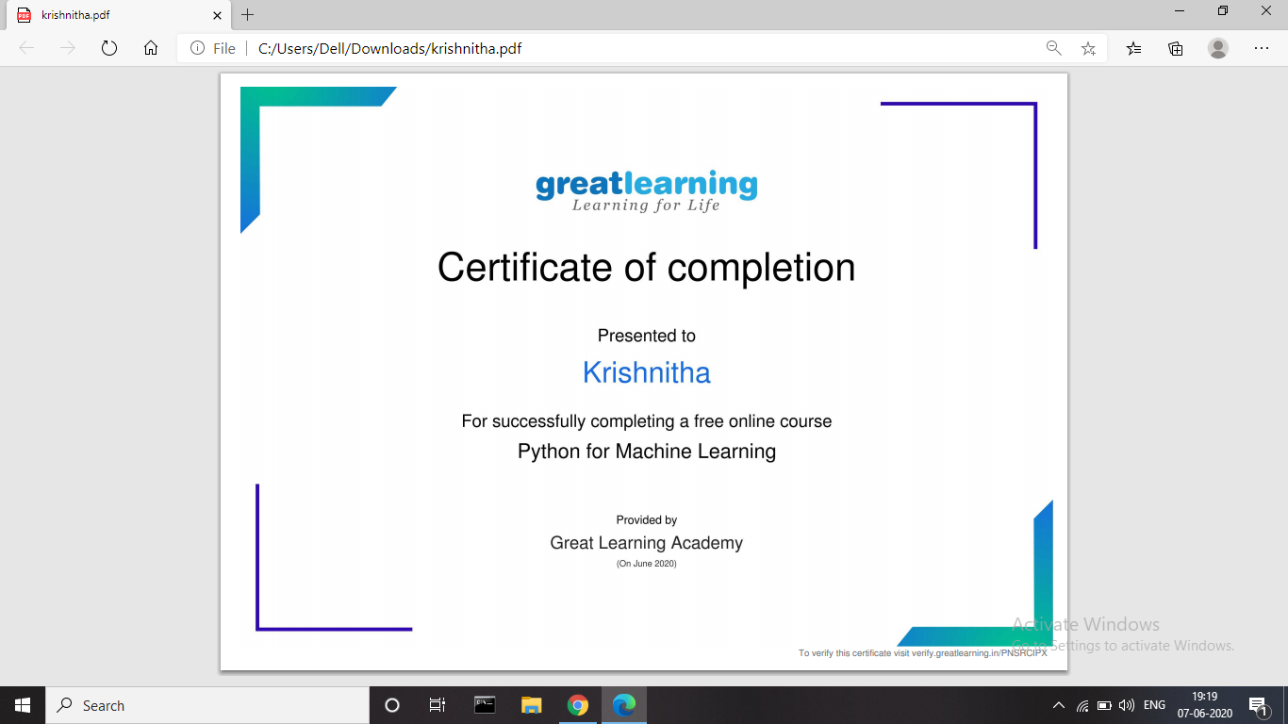

**Coding Challenges Details:**

**Problem:** Write a C++ Program to swap two numbers using friend as a bridge concept.

Note- Don’t make use of temp variable while swapping.

Program should use the concept of friend function

**Example:**

Input

a=10

b=20

Output

a=20

b=10

**Solution:** Uploaded it in GitHub

